**Creating a Production-Grade Workflow**

* **Development Workflow:**

* **Flow specifics:**

* **Dockers Purpose:**

* **Project Generation:**

* **Creating the Dev Dockerfile:**

* **Docker Volumes:**

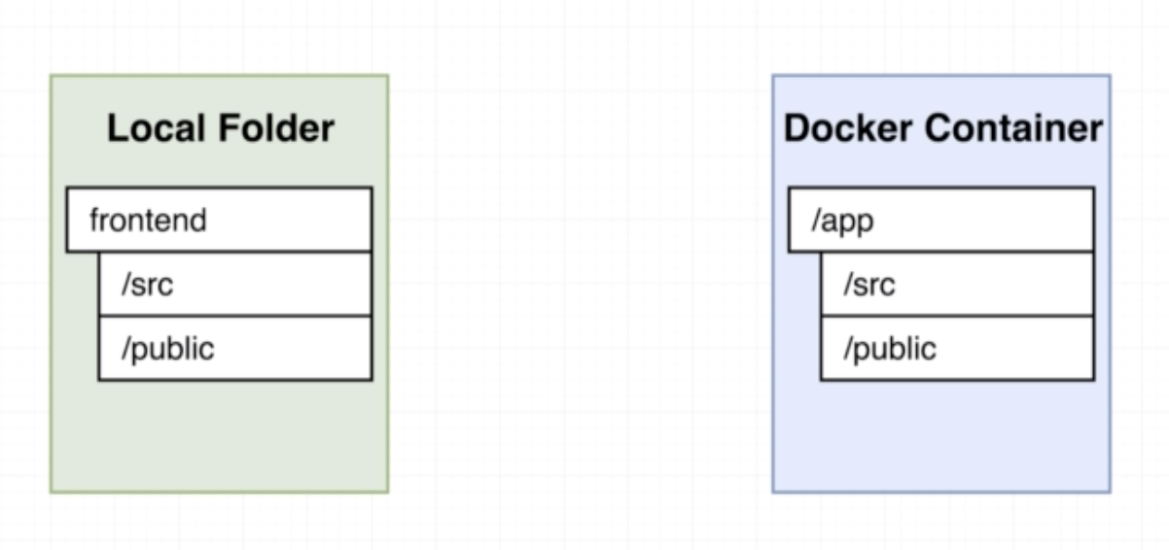

**Volumes:**

Volumes are used to reference the file system which is external to the container to the running container.

This is similar to port mapping (port mapping maps the port of localhost to the port inside the container). In case of volumes we are referencing a file system.

Attaching volume using docke run command:

To map a volume to the container, we need both the run time argument, if we provide just the second argument. It will end up in error.

docker run -it -p 3000:3000 -v $(pwd):/app c66d2c90683c

Reason for above error is, it doesn’t find the node_modules folder.

docker run -it -p 3000:3000 -v /app/node_modules -v $(pwd):/app image_id

* **Running tests on container:**

Build the container using below command.

docker build -f Dockerfile.dev .

docker run image_id npm run test

* **Live updating tests:**

Run the docker-compose up, get the id of the docker by running “docker ps”

Now use the exec command to run the test cases (live update)

docker exec -it container_id npm run test

* **Docker compose for running tests:**

Create another service for running the test inside the docker-compose file as below. Now as it has a different mounting, it will run the test cases whenever there is a change.

Note: With this approach, we will not be able to get the console input control. Whatever you type inside the command, it will not accept anything.

* **Shortcomings on Testing:**

We won’t get the input command even after using the attach, here is the problem behind it.

Docker container creates a different id for each process, in our case we are running npm run test.

But docker is not creating a single process for “npm run test”, it is creating a separate process for “npm” and another one for “run test”. So we were attaching it to the “npm” process not for the test process, because of this it wasn’t working.

Note: Whenever we use “docker attach” it will always attach to the primary process, not to the secondary process.

* **Need for Nginx:**

Note: Whenever we run “npm run build” this will create the output for production.

For development server, it will have it won dev server which takes care of request handling, but for production, we will not have implicit “dev server”. For production we have to use an explicit server.

* **Multi-Step Docker builds:**

* **Implementing Multi-step builds:**